Exp No:16
SERIAL INTERRUPT USING UART (KEYBOARD INPUT) IN KEIL
AIM: To write and simulate an Embedded C program using serial interrupt in 8051 microcontroller such that while a message is continuously transmitted, any key pressed from the keyboard generates an interrupt and is displayed through UART
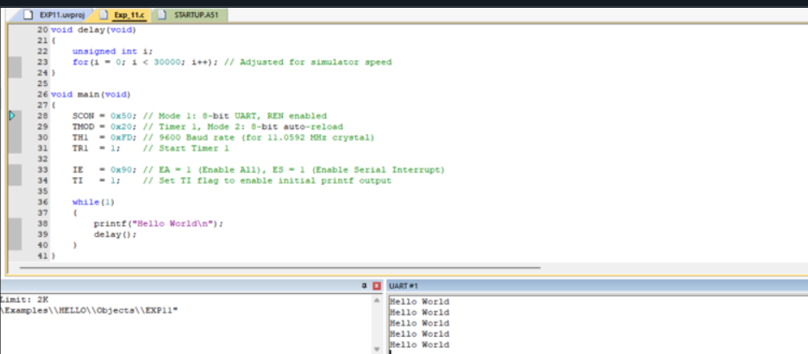
RESULT:
Thus, the serial interrupt using UART was successfully implemented and verified in Keil simulator. The interrupt was triggered upon keyboard input and serviced correctly using an Interrupt Service Routine.

